**Tableau Parts 1 and 2: Exercises with answers**

Exercise 1

1. For these exercises, we will be using the ‘employee’ tables. Import the files **employee.csv** and **department.csv** into Tableau from your data directory.

Answer: Import the .csv files from the data folder with the Connect panel.

1. Combine employee.csv and department.csv using Relationships by dragging the department table into the canvas.

Answer:

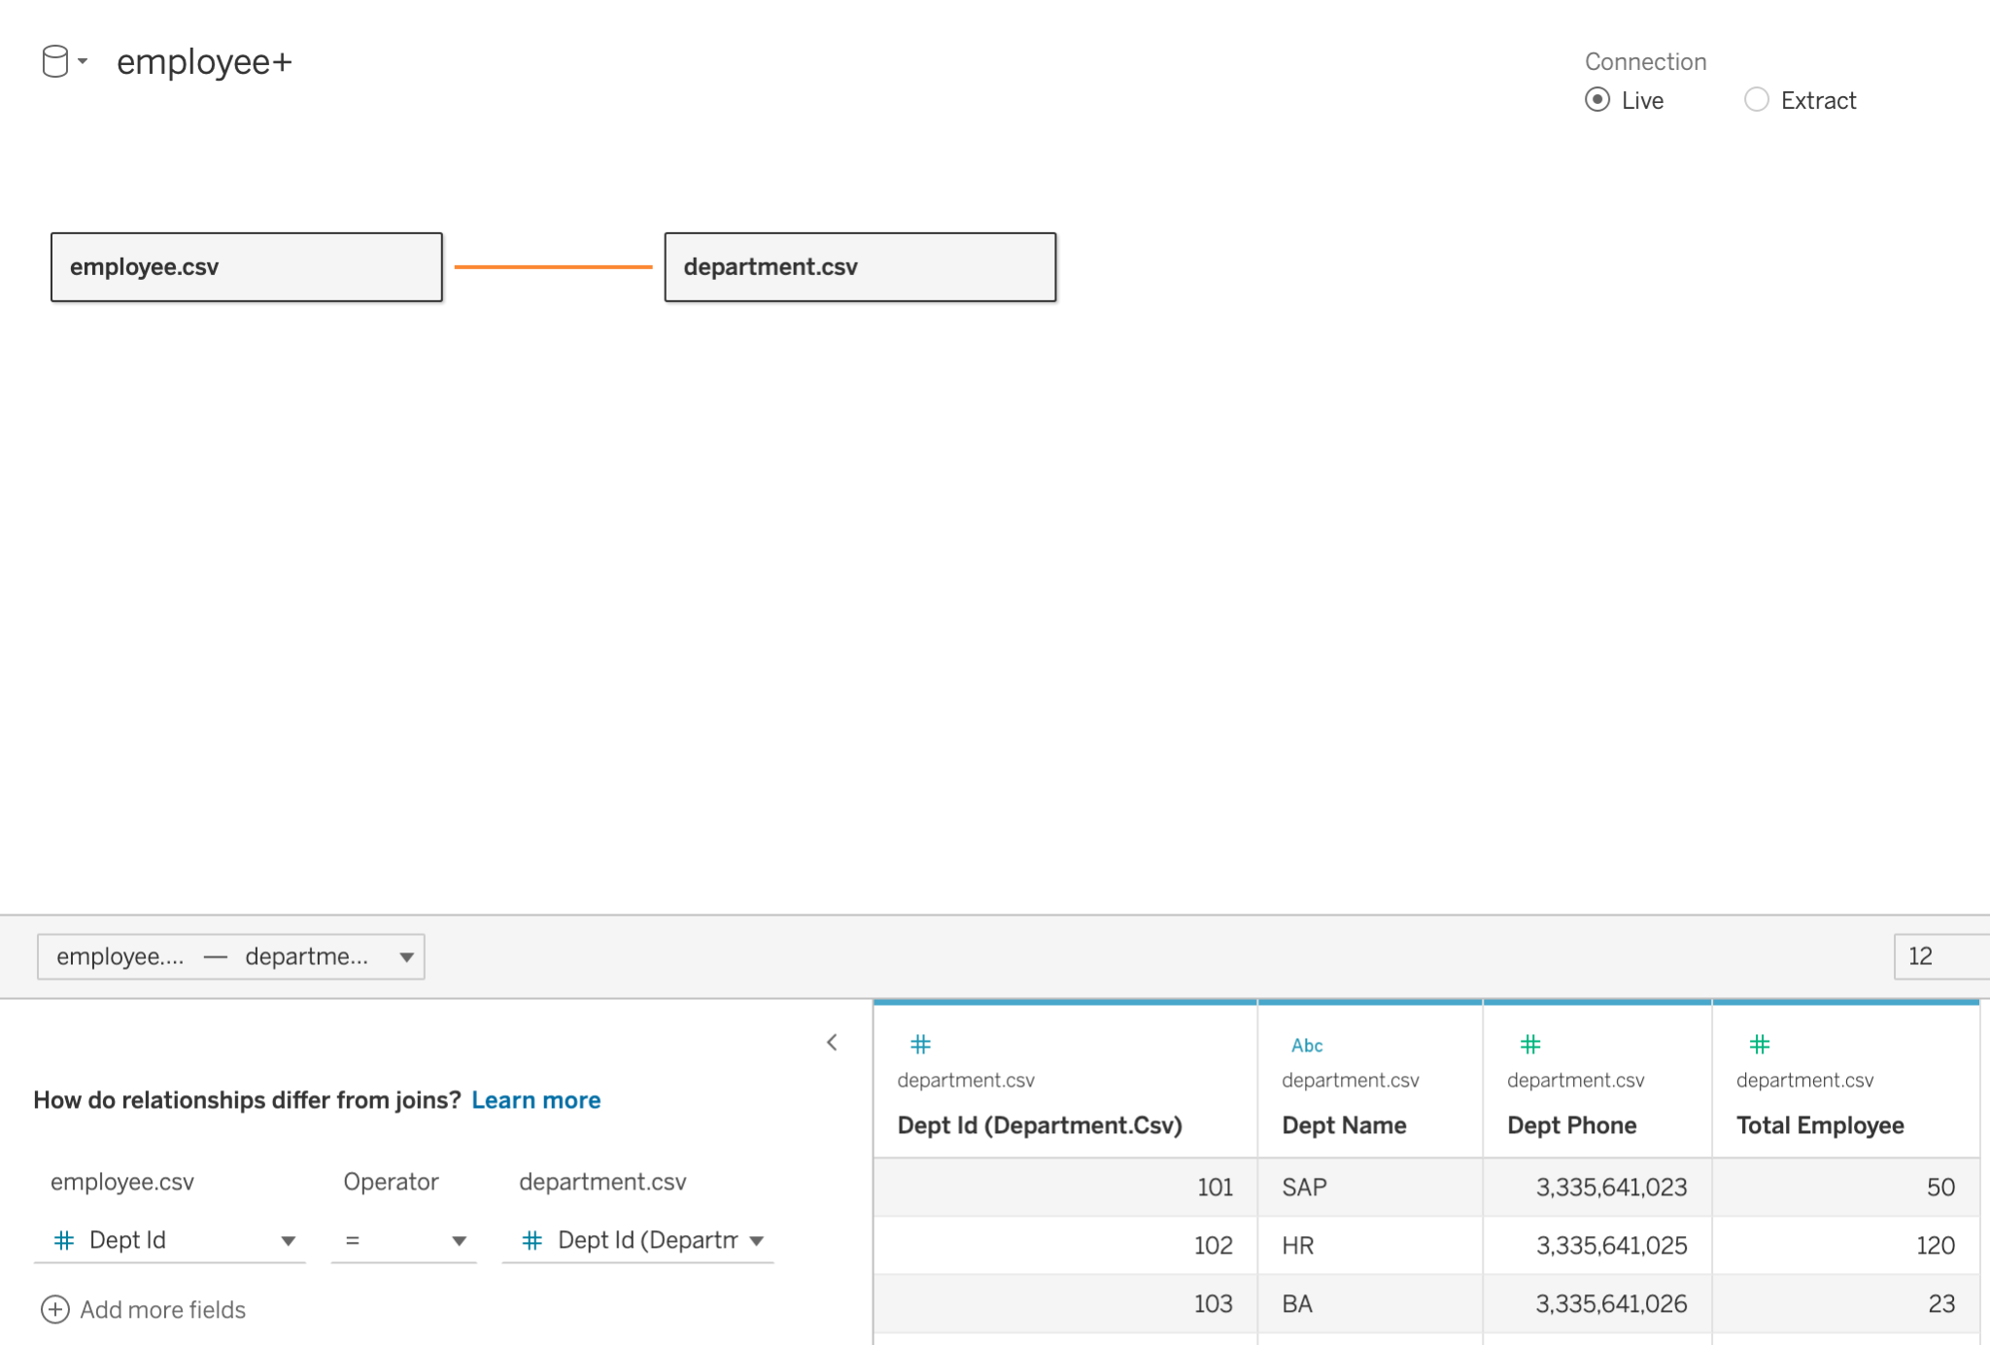

1. Now, import the project table, **project.csv**, and combine it with the employee.csv table using Relationships by dragging project.csv into the canvas.

Answer:

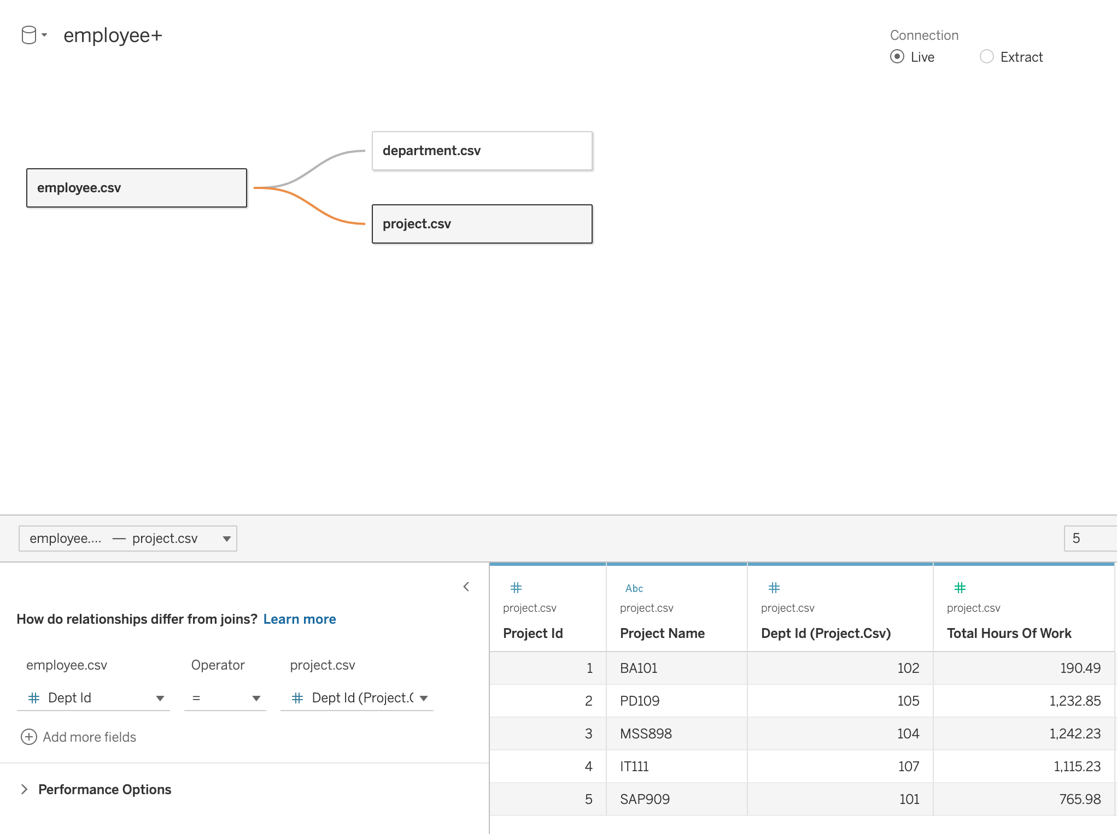

Exercise 2

1. On a new sheet, create a shape plot of Years of Experience vs. Employee Age colored by Dept Name, with Employee ID in the Detail field.

Answer:

* 1. Add Employee Id to the Detail field
  2. Add Employee Age(SUM) to the Column shelf
  3. Add Years of Experience(SUM) to the Row shelf
  4. Add Dept Name to the Color field

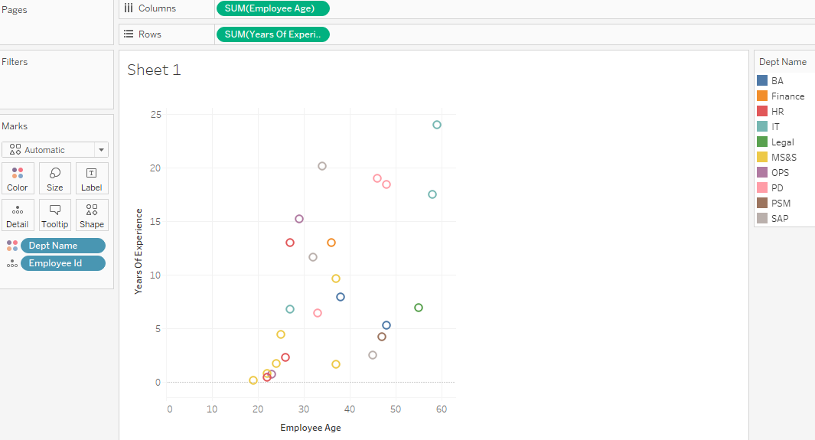

1. On a new sheet, plot a vertical bar chart to show Average Employee Age for each Project Name. Remove the Null bar by right-clicking on it and selecting “Exclude.”

Answer:

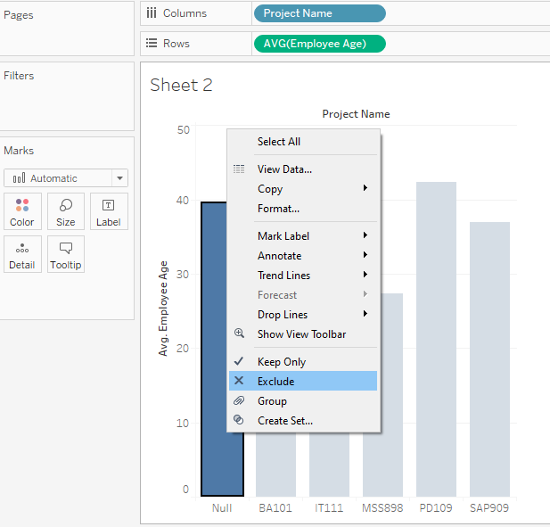

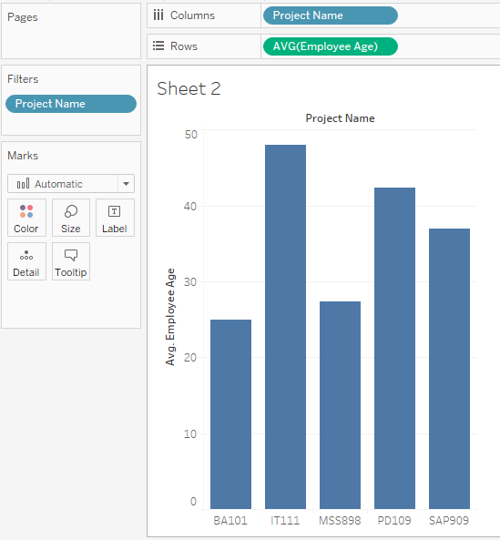

1. Using the Analytics tab, add a Mean (average) line for Employee Age with 95% Confidence Interval (CI) to the chart obtained in Question 2.

What can you infer from the resulting chart?

Answer:

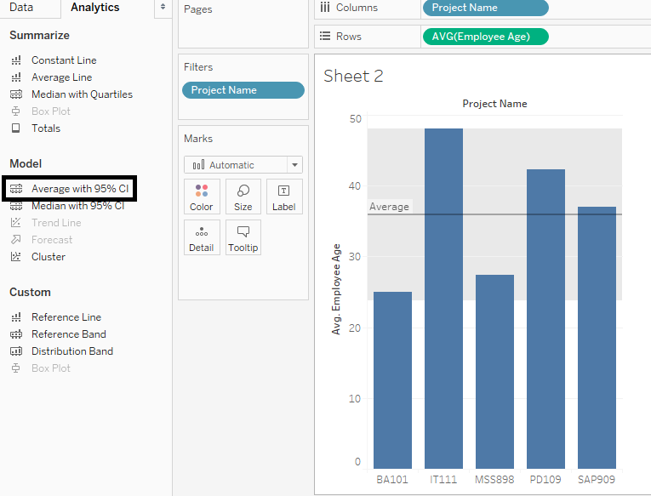

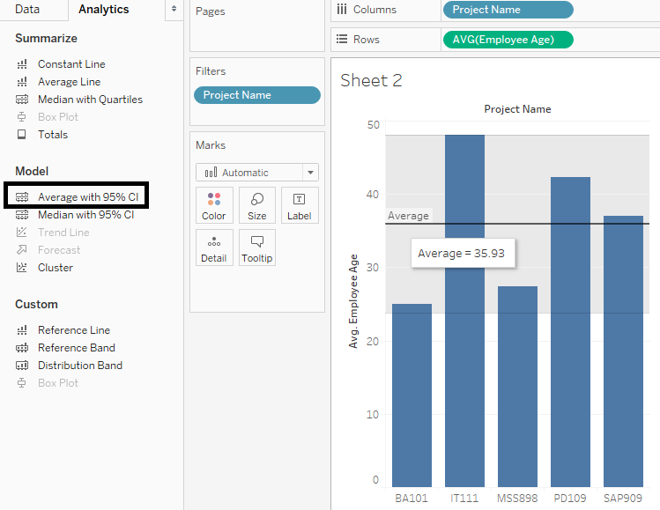

The Mean line shows us the overall Average Employee Age for all Projects.

We can infer that the Average Employee Ages for the Projects BA101 and MSS898 are less than the overall Average Employee Age, while those of IT111, PD109 are greater than the overall Average Employee Age.

We might also infer that the average age of Employees working on the SAP909 project is very similar to the overall average age of all Employees.